# Materials Needed

1. Particle Texture (<https://drive.google.com/file/d/1l5ShxjRMn3b19P83qog1yLXTV9C2VWcr/view?usp=sharing>)
2. Interaction Script (<https://drive.google.com/file/d/1iLaCiV0PbMsJVjW3w3ay1D59daExF6wk/view?usp=sharing>)

# Important Notes

1. This method only works IF the water itself is a **flat plane**. Water with vertex displacement can still work with this method but do be aware that it could break the interactive immersion.
2. The interactive particle itself has no shadow, thus making it look a little “fake” in some sense.
3. Particle system is based on (<https://www.patreon.com/posts/30490169>)

# 

# Particle System Setup

1. Create a new Particle System in your scene
2. Tick the **Prewarm** option**, Start Lifetime** between **2** and **3, Start Speed** to **0, Start Size** between **6** and **8, Start Color** to **White,** and **Simulation Space** to **World  
   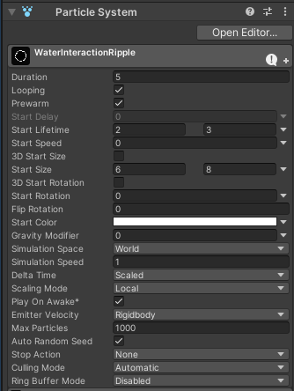**
3. Change the shape to **Edge**, with a very small **Radius (0.1)  
   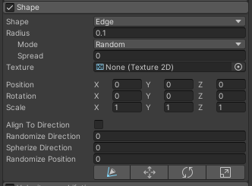**
4. Create a new Material set to **Universal Render Pipeline/Particles/Unlit** and add the above texture. Set the Surface Type to **Transparent**, Blending Mode to **PreMultiply**, and Color mode to **Multiply  
   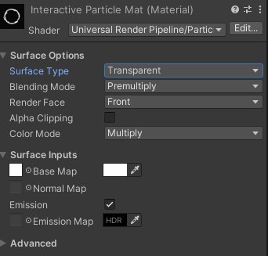**
5. In the Renderer section of the Particle System; Set **Render Mode** to **Horizontal Billboard,** Set **Material** to the new AlphaBlended Ripple Material, and set **Sort Mode** to **Youngest in Front  
   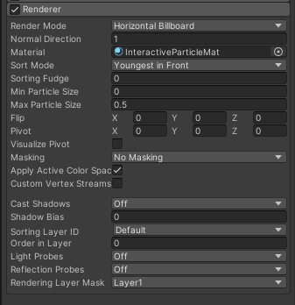**
6. Turn on **Color over Lifetime** and create a gradient of white that blends from and to 0 alpha  
   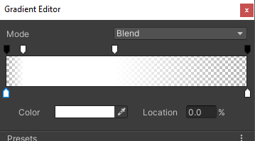
7. Turn on **Size over Lifetime** and make a curve that starts growing quick and then gradually gets higher  
   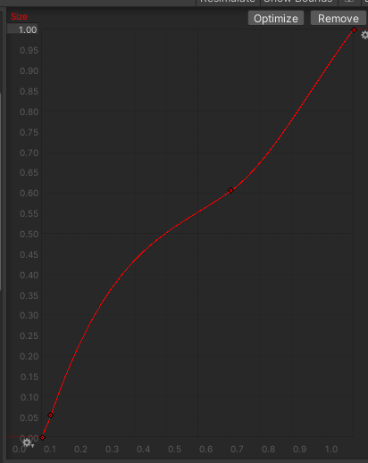
8. Set the **Rate over Time** to between **1** and **2**Set the **Rate over Distance** to **4  
   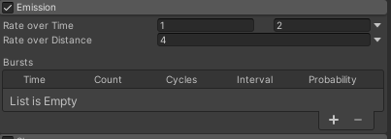**
9. Add the newly created Particle System as a child of the **PlayerArmature  
   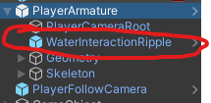**

# Water Collider Setup

1. Create a **Box Collider** for the water mesh itself
2. Tick the **Is Trigger** box

# Script Setup

1. Add the **Water Interaction Script** as a component of the **PlayerArmature**  
   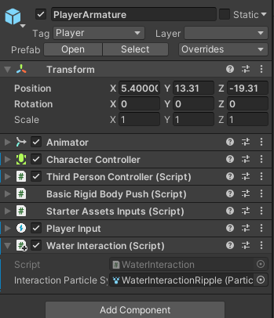
2. Drag the **Particle System** into the **Interaction Particle System parameter** of the script